Other feedback:
Remove
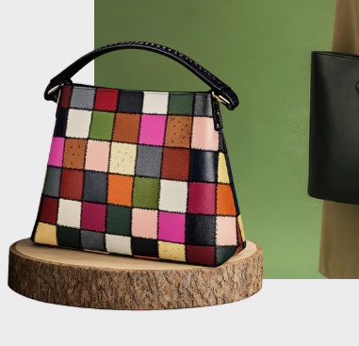
Remove
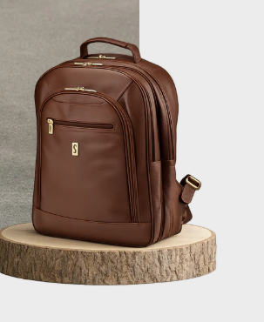

Place Collection part after Men and Women
- Should be SILKSKIN Collection
- Men’s Wallets
- Women’s Wallets
- Card Holders
- Men’s Bags
- Men’s Accessories
- Women’s Handbags
- Maroon – not Mahroon
- SILKSKIN – not SilkSkin

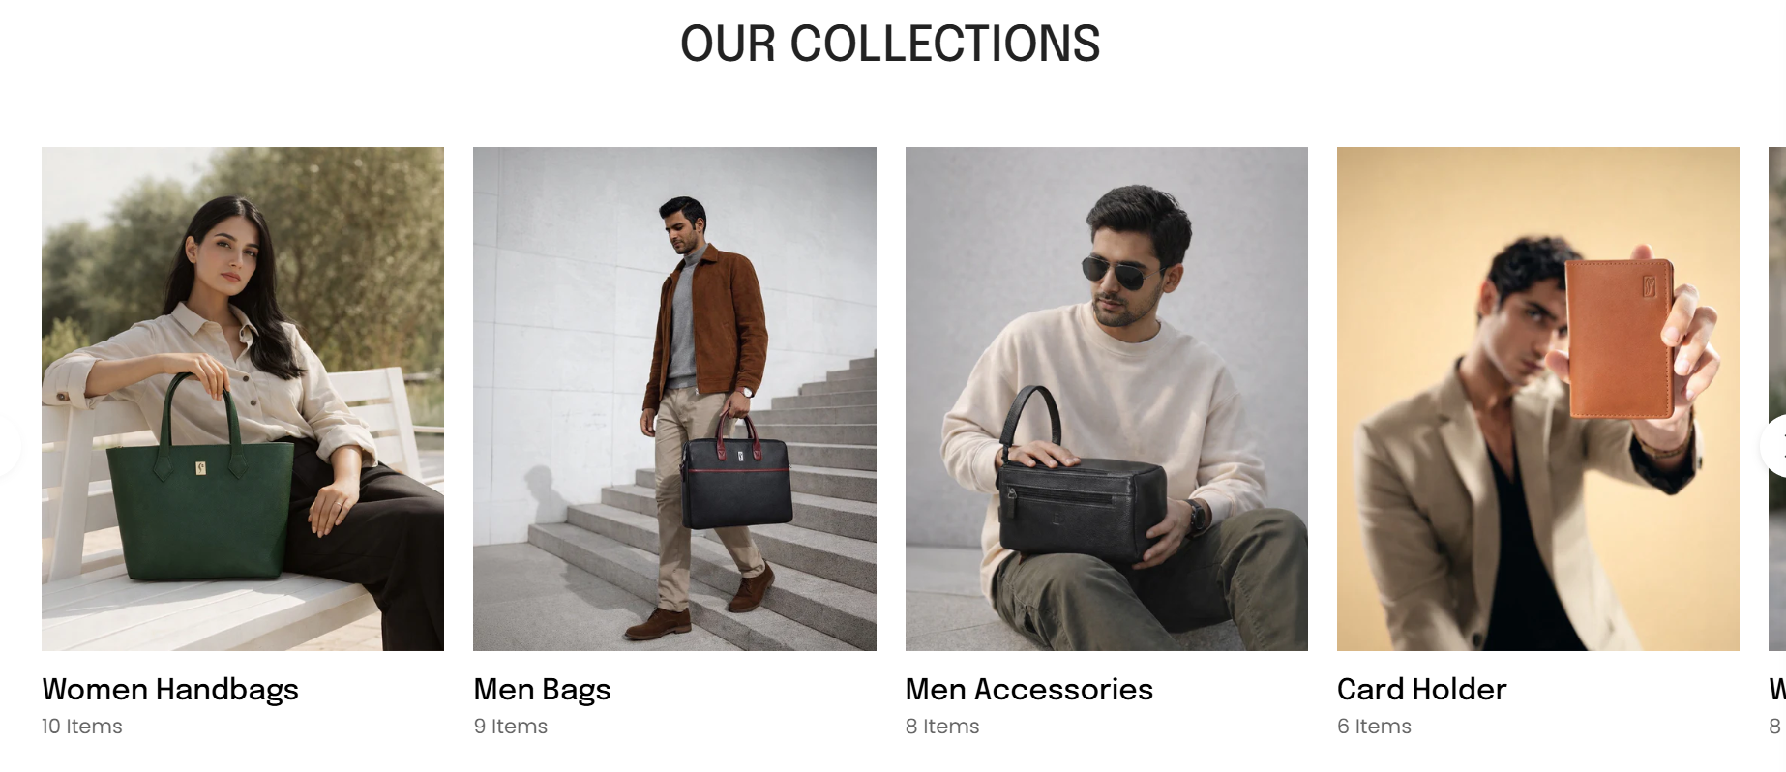

SILKSKIN – not SilkSkin

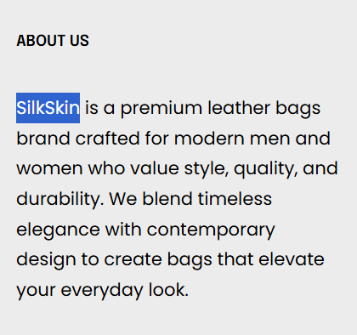

Logo is blurred

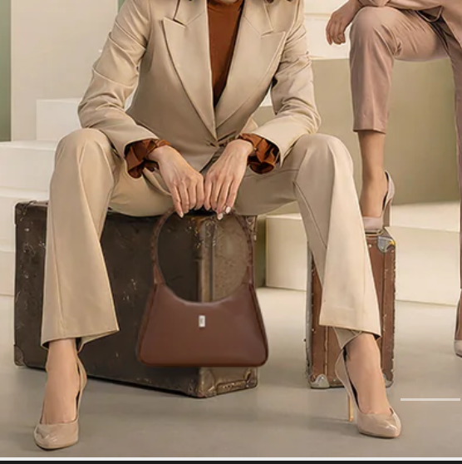
Be careful about Upper/Lower case:
We understand that a man…
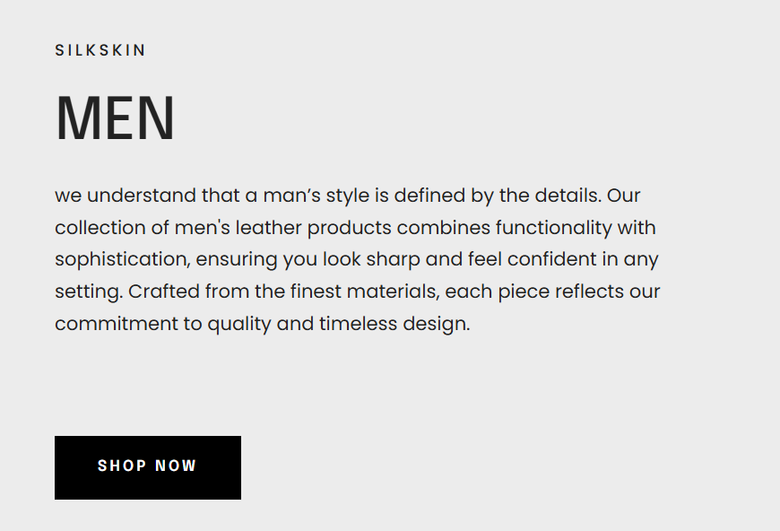

- For font, color theme and design please refer to design guide shared
- For imagery and AI generated product videos please see this website:
Leather Weekend Bag Palissy · CarlFriedrik

What is also missing:
A section about SILKSKIN being a leather brand with leather imagery. See example below:
